**OS/ Linux Assignment 1**

**Name : Atharva Karkar**

**Roll number: 8**

**Course:**  **MCA DATA SCIENCE (2023-25)**

1. Ls: Lists the information about all the files (current directory by default).

Output :

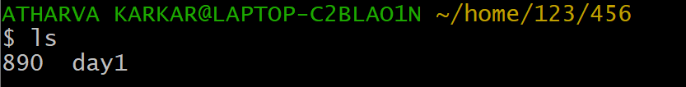

1. Pwd: Lists the present directory.

Output: 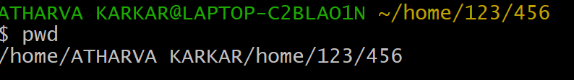

1. Ls – l : lists all the directories in long format

Output : 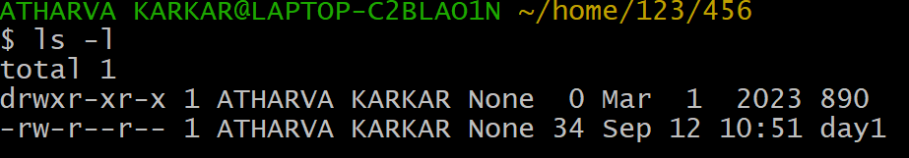

1. Ls -la:

Output: 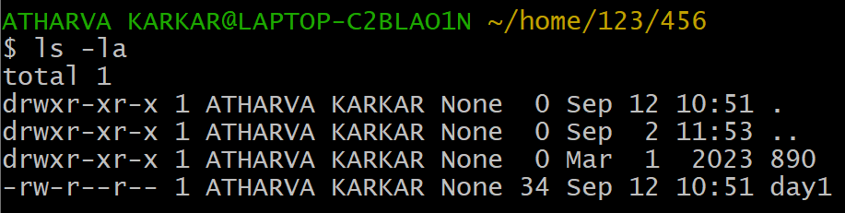

1. Cd .. : Lists the parent directory

Output: 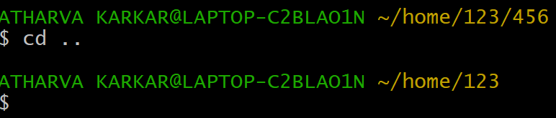

1. Cd . : used to change the current directory

Output: 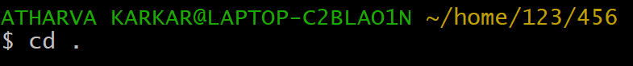

1. Cd directory_name : jumps to a specific mentioned directory.

Output : 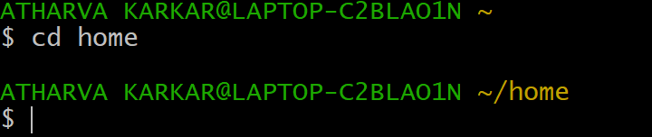

1. Touch : used to create empty file

Output:

1. Cat > file name: create and insert

Output : 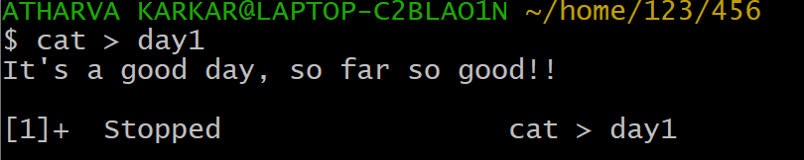

1. Cat >> file name: append to file

1. Cat file name: open file

Output : 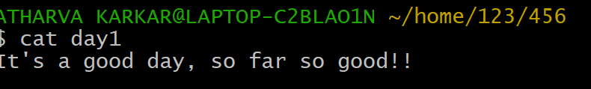

1. Clear: Clears the screen/terminal

Output:

1. Mkdir: create a directory

Output : 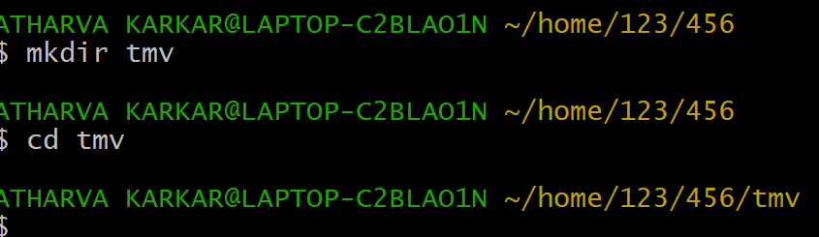

1. Man : open manual

Output : 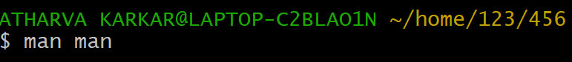

1. Cp : copy the content of a file

Output :

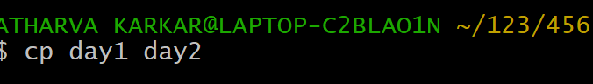

1. Cp – r : copy a file into directory

Output :

1. Open : opens a file

Output : 

1. Find : to find a specific files

Output : 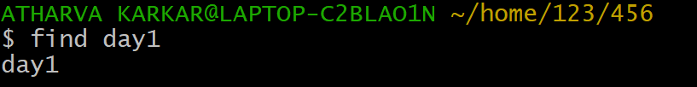

1. Gzip: used to compress a file

Output :

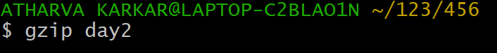

1. Less : shows less content of that file.

Output:

1. Sort : used for so

Output : 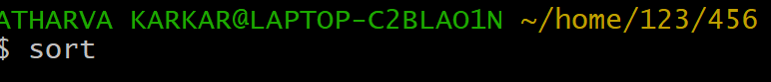

1. Gunzip: Used for file decompression.

Output :



1. Rmdir : removes / deletes a specific mentioned directory

Output : 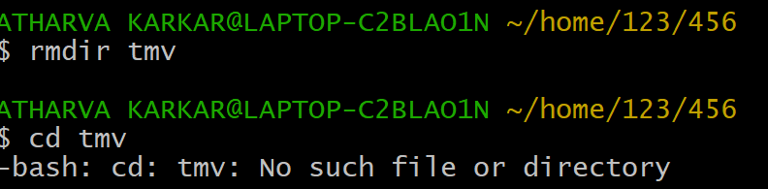

1. Tail : display the last content of a file

Output: 

1. rm : used to remove files or directories.

